HANGMAN GAME USING PYTHON & SQL

INTERDISCIPLINARY PROJECT

Submitted in partial fulfillment of the requirements for the award of Bachelor of Engineering degree in Computer Science and Engineering

By

BANDARU RAMYA CHANDRA RISHITHA
Reg. No–41110167


DEPARTMENT OF COMPUTER SCIENCE AND ENGINEERING

SCHOOL OF COMPUTING

SATHYABAMA

INSTITUTE OF SCIENCE AND TECHNOLOGY (DEEMED TO BE UNIVERSITY)
CATEGORY - 1 UNIVERSITY BY UGC
Accredited with Grade “A++” by NAAC I Approved by AICTE JEPPIAAR NAGAR, RAJIV GANDHI SALAI, CHENNAI - 600119

APRIL - 2025



DEPARTMENT OF COMPUTER SCIENCE AND ENGINEERING

BONAFIDE CERTIFICATE

This is to certify that this Interdisciplinary Project Report is the bonafide work of BANDARU RAMYACHANDRA RISHITHA (Reg. No–41110167) who carried out the Project entitled “HANGMAN GAME” under my supervision from January 2025 to April 2025.

Internal Guide
Dr. M.D. ANTO PRAVEENA, M.E., Ph.D.,

Head of the Department
Dr. L. LAKSHMANAN, M.E., Ph.D.,

Submitted for Interdisciplinary Project Viva Voce Examination held on-----------------------

Internal Examiner External Examiner

DECLARATION

I, BANDARU RAMYA CHANDRA RISHITHA (Reg. No–41110167), hereby declare that the Interdisciplinary Project Report entitled “HANGMAN GAME” done by me under the guidance of Dr.M. D. ANTO PRAVEENA, M.E., Ph.D., is submitted in partial fulfillment of the requirements for the award of Bachelor of Engineering degree in Computer Science and Engineering.

DATE:

PLACE: Chennai SIGNATURE OF THE CANDIDATE

ACKNOWLEDGEMENT

I am pleased to acknowledge my sincere thanks to Board of Management of Sathyabama Institute of Science and Technology for their kind encouragement in doing this project and for completing it successfully. I am grateful to them.
I convey my thanks to Dr. T. Sasikala M.E., Ph. D, Dean, School of Computing, and Dr. L. Lakshmanan M.E., Ph.D., Head of the Department of Computer Science and Engineering for providing me necessary support and details at the right time during the progressive reviews.
I would like to express my sincere and deep sense of gratitude to my Project Guide Dr.
M.D.Anto Praveena M.E., Ph.D. for her valuable guidance, suggestions, and constant encouragement paved way for the successful completion of my project work.
I wish to express my thanks to all Teaching and Non-teaching staff members of the Department of Computer Science and Engineering who were helpful in many ways for the completion of the Interdisciplinary project.

TRAINING CERTIFICATE

ABSTRACT

Hangman is a captivating single-player game that challenges your wit and educational skills. At its core, the game presents a mystery word concealed by blank spaces, and your objective is to reveal this word letter by letter before a hangman figure is fully drawn on the screen. With each guess you make, you either uncover part of the word or risk adding to the hangman's silhouette, bringing you closer to either victory or defeat. The strategy in this game is key. Correctly guessing a letter fills in its corresponding blanks, gradually revealing the hidden word. However, an incorrect guess leads to the construction of the hangman, limiting your number of attempts. Therefore, thoughtful and strategic letter selection is essential for success. Success in Hangman relies heavily on deductive reasoning. Initially, common letters like "E" and "T" are often guessed first due to their frequency in English words. As more letters are unveiled, the game becomes more challenging, requiring players to analyze the word's length and the revealed pattern to decipher the remaining letters. This progression transforms Hangman from a simple guessing game into a mental exercise that enhances vocabulary and sharpens deductive reasoning skills.

TABLE OF CONTENTS

CHAPTER NO.
TITLE PAGE
ABSTRACT v
NO.
LIST OF FIGURES vii
LIST OF TABLES viii

- INTRODUCTION 1
- LITERATURE SURVEY
  - Review on Existing System 5
  - Inferences and Challenges in Existing System 5
- ANALYSIS AND DESIGN OF PROPOSED SYSTEM
  - Functional Requirements 6
  - Hardware and Software Requirements 6
- IMPLEMENTATION OF PROPOSED SYSTEM
  - Selected Methodology 11
  - Architecture of Proposed System 12
  - Description of Modules 13
  - Implementation 14
- RESULTS AND DISCUSSION
  - Analysis and Discussion of Results 17
  - Future Enhancements 19
- CONCLUSION 21
REFERENCES 23
APPENDIX 26
- SOURCE CODE 26
- SCREENSHOTS 28

LIST OF FIGURES

FIGURE NO.
FIGURE NAME PAGE
NO

LIST OF TABLES

TABLE NO.

TABLE NAME PAGE
NO.

  - Financial report on estimated costing 16

CHAPTER 1 INTRODUCTION
The Internet of Things also known as IOT is a system of interrelated computing
devices, machines, objects, animals, or people that are provided with unique identifiers and the ability to transfer data over a network without requiring human-to-human or human-to-computer interaction. Nowadays IOT is being used in many fields such as home automation, wearable smart appliances, smart agriculture, etc. Since it helps mutual communication between the devices and the people over the network.

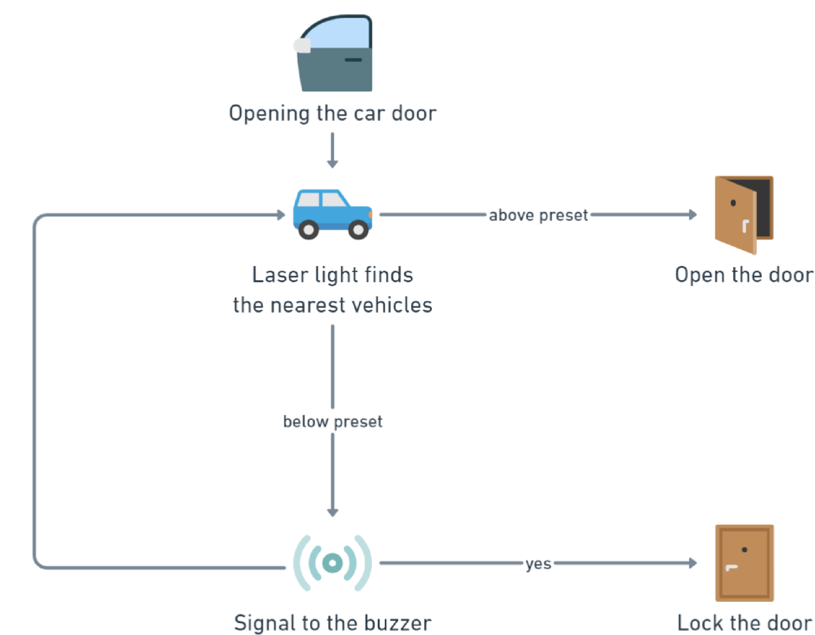
Fig. 4.1 Workflow of the Car Door Locking Mechanism

Table 3.1 Sample Table

REFERENCES

- Abd Kadir, Muhamad M, et al., IoT based car parking management system using IR sensor, Journal of Computing Research and Innovation, 5(2), 2020, 75-84.
- Aly M., Real-time detection of lane markers in urban streets, 2008 IEEE Intelligent Vehicles Symposium, 2008, 7–12.
[3] Azshwanth D., Koshy M.T., Balachander T., Automated car parking-system, Journal of Physics: Conference Series, 1362(1), 2019, 01205.
[4]. Bertozzi M., Broggi A., Real-time lane and obstacle detection on the gold system, Proceedings of Conference on Intelligent Vehicles, 1996, 213–218.
[5]. Chaudhary H., Bansal P., Valarmathi B., Advanced CAR parking system using Arduino, ICACCS, 2017.
[6]. Hoel, Carl-Johan, Wolff K., Laine L., Automated speed and lane change decision making using deep reinforcement learning, IEEE, 2018.

APPENDIX

SOURCE CODE
#include <SPI.h> #include <Wire.h>
#include <Adafruit_GFX.h>

PAPER PUBLICATION

2024 International Conference on Circuit Power and Computing Technologies (ICCPCT)

SMART HELMET USING IOT

Dr.P.Asha
Computer Science and Engineering Sathyabama Institute of Science and Technology
Chennai,India ashapandian225@gmail.com
Akshara C V
Computer Science and Engineering Sathyabama Institute of Science and Technology
Chennai,India
Aakash S
Computer Science and Engineering Sathyabama Institute of Science and Technology
Chennai,India aakashak@gmail.com

Acceptance – Intimation
On behalf of the Technical Program Committee of the “International Conference on Circuit Power and Computing Technologies”, ICCPCT-2024, we are pleased to inform you that your paper has been accepted for oral presentation. Camera ready submission, copyright form submission and view review options were enabled for the selected paper in your CMT author console. All the papers selected and presented will be published in IEEE Digital Xplore , indexed by Scopus. You can complete the registration process within a week from the date of acceptance.The conference will be conducted on 8th & 9th August 2024. The detailed conference schedule will be send to you later. All review comments and suggestions should be incorporated while preparing camera ready paper. Review comments are available in CMT account>author console>view reviews.

PAYMENT PROOF SCREENSHOT

